# Mapping Script

The script creates maps and text relating to a data request as specified. There are options:

* To create different types of maps
* To extract citation documents
* To search based on a grid reference or a shapefile
* To specify a search radius

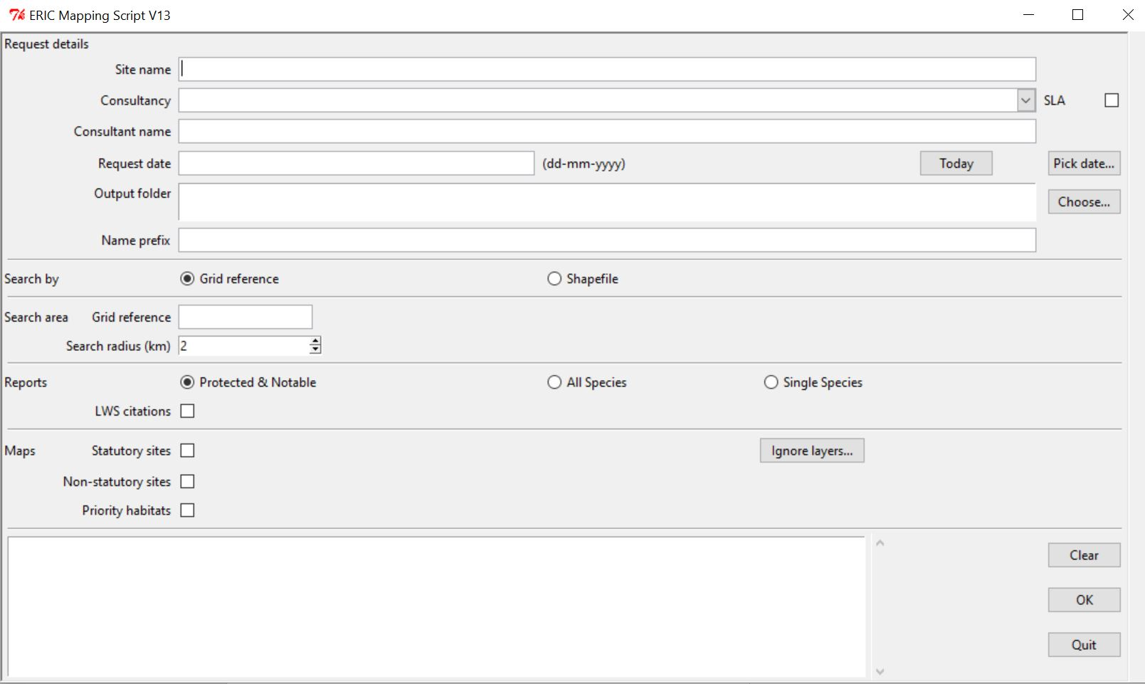

## Outputs

* Text file containing the text of an e-mail to send to the client with the data.
* Statutory/non-statutory site map – created if the option is selected and there are any sites in the search area
* Priority habitats map – created if the option is selected
* Zip file of citation documents – created if the option is selected and documents exist relevant to the search area
* A folder of working files – mainly shapefiles. The search area shapefile is used within QGIS to perform the data search. Sometimes clients want the shapefiles relating to the wildlife sites on the map. If so they need to sign an OS licence agreement.

## Requirements

The script interacts with ArcMap templates so the PC must have a licensed version of ArcMap installed.

Two additional Python scripts are needed:

* datepick.py
* mapsupportv2.py

In each case a compiled .pyc version will be created the first time the script runs.

## INI file

Options for the script are specified in an INI file called “config.ini”. This enables it to be used on PCs with different setups. The three options are:

* map_script – the location of the map template
* lws_mappings – the location of a file that configures the citation documents
* dir_root – the root directory for saving output files

Example values:

map_script = r'C:\ERIC\Maps\Layers\Commercial Data Request Map Template.mxd'   
lws_mappings = r'C:\ERIC\Data requests\Script\LWS file mappings 3 - for script.txt'   
dir_root = r'C:\ERIC\Data requests\Requests'

## Citation file mapping

The file ”LWS file mappings 3 - for script.txt” contains details of the citation documents. This is a tab delimited file which needs a row for each site for which we have citation documents.

The fields in the file are:

* Sitename
* Siteid
* Local authority – the local authority to which the site relates
* Filename – the name of the citation file including the path

The sitename and siteid for each document must match the corresponding attributes in the LWS site shapefile for that local authority.

Typically the file paths will need to be changed when setting up the script on a different PC. The other values will only need to be changed if the documents we hold are changed

Example of start of the file:

SITENAME   SITEID         Local Authority        Filename including path  
Pontburn Wood       1.1      Durham         C:\ERIC\LWS Citations\Durham\LWS Citations\Derwentside - 1\Derwentside LWS PDFs\1.1 Pontburn Wood.pdf  
West Wood   1.10    Durham         C:\ERIC\LWS Citations\Durham\LWS Citations\Derwentside - 1\Derwentside LWS PDFs\1.10 West Wood.pdf  
Sodfine and Howden Wood          1.11    Durham          C:\ERIC\LWS Citations\Durham\LWS Citations\Derwentside - 1\Derwentside LWS PDFs\1.11 Sodfine & Howden Woods.pdf

**Note: don’t open the file in Excel as this can change some of the site ids and cause the documents not to be found.**

## Map templates

The script uses two ArcMap templates:

* Commercial Data Request Template.mxd – used for statutory/non-statutory site maps
* Priority Habitat MapTemplate.mxd – used for priority habitat maps

The templates contain various layers which are displayed in the output such as the LWS sites for each authority or the SSSIs for the region. They also contain some template layers that are used to define formatting in the output. Finally a number of the layers define areas within the region which are used to flag other functionality in the script. For example the “Durham Bat Group area” layer dictates whether to mention the bat group in the text file output.

The templates include copyright text which includes the current year. This text need to be updated in January each year.

## Code overview

* Check input parameters
* Create buffer layer based on grid ref and radius or search area in shapefile
* Compare the buffer layer with layers in the Commercial Data Request Map template to see whether the search will involve one of the bird/bat groups or intersect the waxcap region
* If requested create and output Priority Habitat map
* If stat and/or non-stat map is required select the appropriate layers and create map
* If citation documents are needed check if there are any non-stat sites in the search area and whether we have documents. If so create a zip file containing the documents.
* Write text file for e-mail based on parameters selected & whether data will include bird clubs, etc. Includes calculation of the cost.

Anne Donnelly – 18/07/22